CLOUD COMPUTING
What is Cloud Computing?
Cloud computing is the delivery of computing services—including servers, storage, databases, networking, software, analytics, and intelligence—over the internet (“the cloud”) to offer faster innovation, flexible resources, and economies of scale. You typically pay only for cloud services you use, helping you lower your operating costs, run your infrastructure more efficiently, and scale as your business needs change.

Advantages of Cloud Computing
Cloud computing is a big shift from the traditional way businesses think about IT resources. Here are seven common reasons organizations are turning to cloud computing services:
- Cost
Moving to the cloud helps companies optimize IT costs. This is because cloud computing eliminates the capital expense of buying hardware and software and setting up and running onsite datacenters—the racks of servers, the round-the-clock electricity for power and cooling, and the IT experts for managing the infrastructure. It adds up fast.
- Speed
Most cloud computing services are provided self service and on demand, so even vast amounts of computing resources can be provisioned in minutes, typically with just a few mouse clicks, giving businesses a lot of flexibility and taking the pressure off capacity planning.
- Global scale
The benefits of cloud computing services include the ability to scale elastically. In cloud speak, that means delivering the right amount of IT resources—for example, more or less computing power, storage, bandwidth—right when they’re needed, and from the right geographic location.
- Productivity
Onsite datacenters typically require a lot of “racking and stacking”—hardware setup, software patching, and other time-consuming IT management chores. Cloud computing removes the need for many of these tasks, so IT teams can spend time on achieving more important business goals.
- Performance
The biggest cloud computing services run on a worldwide network of secure datacenters, which are regularly upgraded to the latest generation of fast and efficient computing hardware. This offers several benefits over a single corporate datacenter, including reduced network latency for applications and greater economies of scale.
- Reliability
Cloud computing makes data backup, disaster recovery, and business continuity easier and less expensive because data can be mirrored at multiple redundant sites on the cloud provider’s network.
- Security
Many cloud providers offer a broad set of policies, technologies, and controls that strengthen your security posture overall, helping protect your data, apps, and infrastructure from potential threats.

Cloud Computing Models
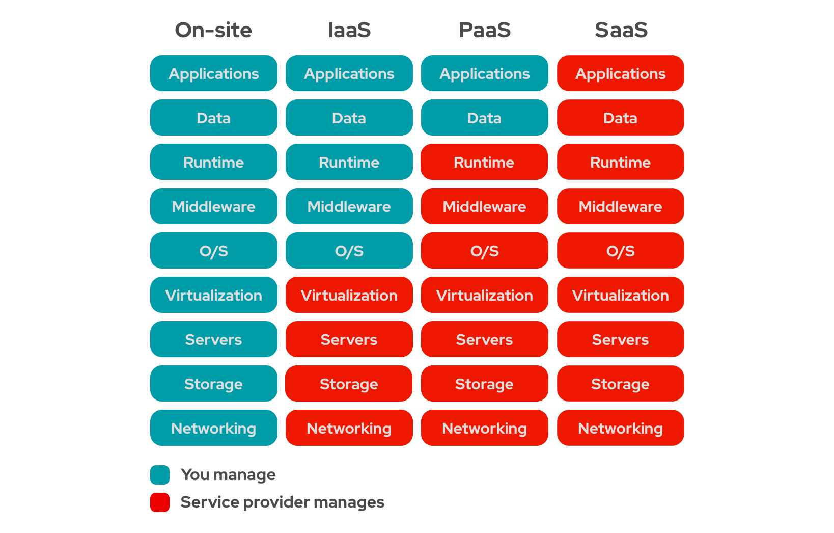

1. IaaS (Infrastructure as a Service)
- What it is: Rents basic, virtualized computing hardware over the internet—including servers, storage space, and networking components.
- our responsibility: You manage the Operating System (OS), middleware, runtime, applications, and data.
- Provider's responsibility: The physical hardware, data centers, and virtualization layer.
- Examples: Amazon Web Services (AWS) EC2, Microsoft Azure Virtual Machines, Google Compute Engine.
- Best for: IT administrators and developers who want maximum control over their infrastructure.
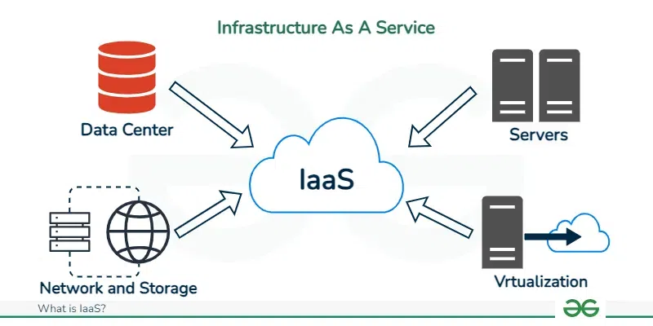

2. PaaS (Platform as a Service)
- What it is: Provides a ready-to-use cloud platform and development environment (tools, databases, runtimes) so you can build, test, and deploy applications without worrying about the underlying hardware.
- our responsibility: Your custom applications and application data.
- Provider's responsibility: The hardware, operating systems, and developer tools/runtimes.
- Examples: Heroku, AWS Elastic Beanstalk, Google App Engine.
- Best for: Software developers who want to write code without managing servers.
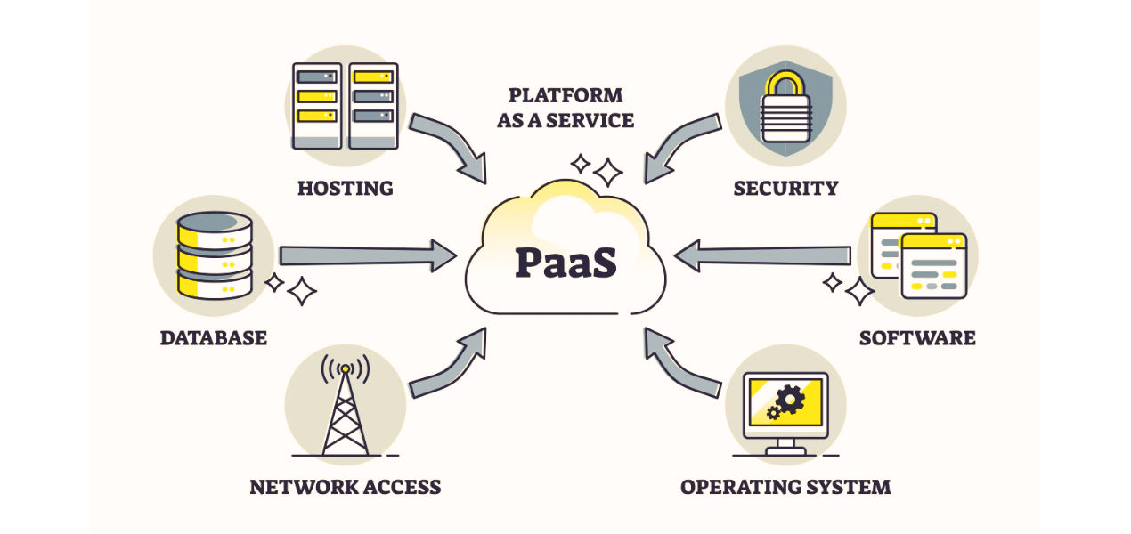

3. SaaS (Software as a Service)
- What it is: Delivers complete, fully functional software applications over the web, accessed via a browser or client.
- our responsibility: Only your user accounts, access permissions, and data.
- Provider's responsibility: Everything else—servers, security, maintenance, updates, and the application itself.
- Examples: Gmail, Microsoft 365, Dropbox, Salesforce.
- Best for: Everyday end-users who need ready-to-run business or personal tools.
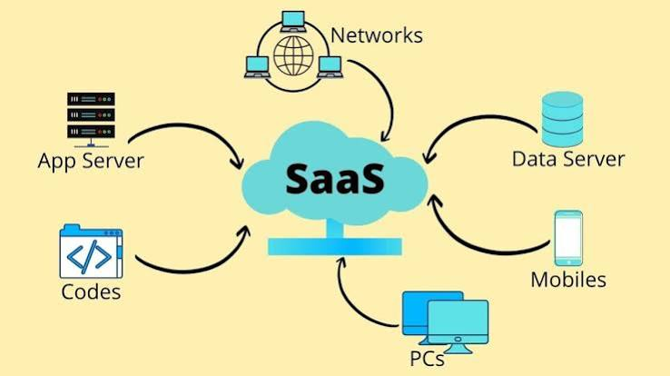

Azure Cloud
What is Microsoft Azure?
Microsoft Azure is a cloud computing platform developed by Microsoft.
It provides services that allow individuals and organizations to build, deploy, manage and scale applications through Microsoft's global cloud infrastructure.
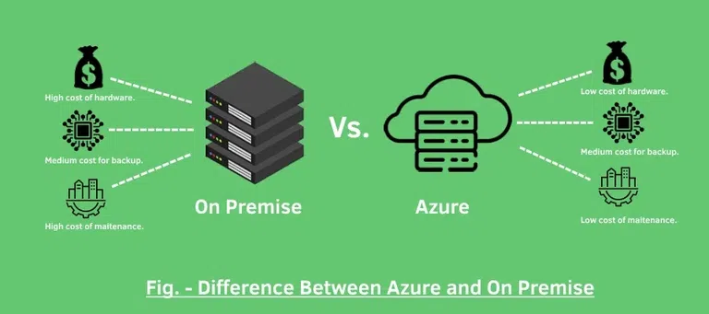
Azure supports:
- Application development.
- Virtual machine hosting.
- Database management.
- Data engineering and analytics.
- Artificial intelligence and machine learning.
- Networking and security.
- Backup and disaster recovery.
Examples of Azure services:
• Compute: Azure Virtual Machines and Azure App Service.
- Storage: Azure Blob Storage.
- Database: Azure SQL Database.
- Networking: Azure Virtual Network.
Example: An online shopping application can run on Azure App Service, store customer and order details in Azure SQL Database, and store product images in Blob Storage.
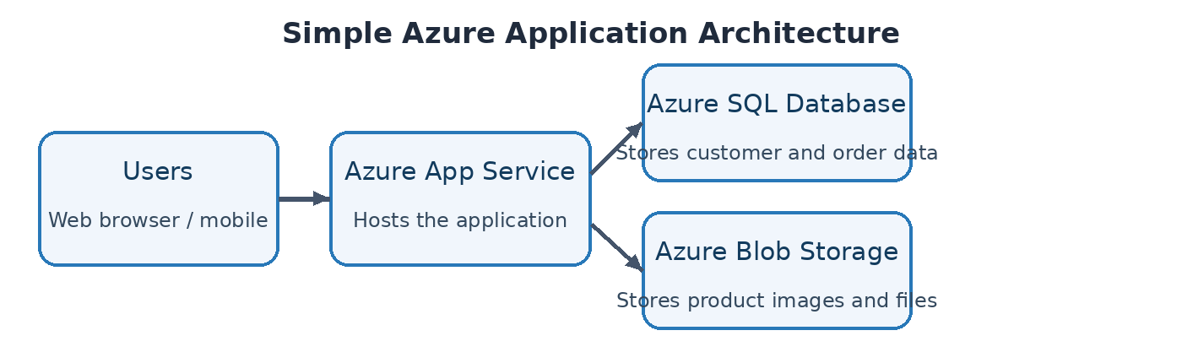
Virtual Machine
A virtual machine (VM) is a computer inside your computer.
It is a software-based emulation of a physical computer. It runs its own operating system (like Linux or Windows) and applications just like a real, physical machine, using a slice of your actual computer's processor, memory, and storage.



